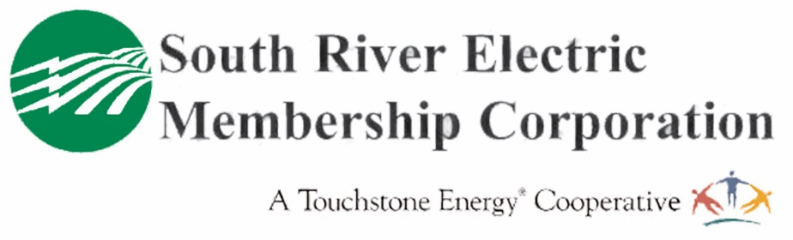
Member Wellness Questionnaire
Keeping everyone safe, healthy and well is our highest priority. We are asking each member who visits our office to complete this questionnaire the day of the appointment. Please email this completed form to billing@sremc.com or bring it with you to your appointment.
Name: Date:
(Please Print)

Phone Number:

- Are you running a temperature 100.4 degrees or higher? Yes No
If you don’t have a thermometer, South River EMC will make a non-contact thermometer available for you to check your temperature prior to your appointment.
- Have you had any of the following symptoms over the past seven days? (check if yes)
fever (over 100.4) or chills/shaking with chills

sore throat

cough

headache

muscle pain

shortness of breath or difficulty breathing

“new” loss of taste or smell
Please answer the following questions pertaining to the previous 14 days:

Yes No Have you or someone that you have been in close contact with (6 feet or less)
been diagnosed with COVID-19, or is presumed to have COVID-19?

If you answer yes to any of these questions, South River EMC will need to reschedule your meeting. An alternate option is to take advantage of our video chat option. Information is available at www.sremc.com.

Preparing for your appointment:
- Please complete the questionnaire and return it to billing@sremc.com or print the completed form and bring it with you to the appointment.
- Consider wearing a mask for your appointment. If you do not have one, we will provide one for you.
- Arrive at your appointment on time and text or call 919.820.1387 for an appointment in the Fayetteville office and 919.820.1814 for an appointment in Dunn. An MSR will greet you at the door.
- Please be prepared to honor social distancing guidelines while interacting with South River EMC employees.

Thank you for taking the time to complete this questionnaire. We appreciate your patience and support.

*Information will destroyed after 30 day.

