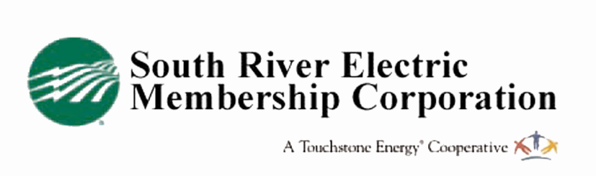
Mail to:
South River EMC
I & W Rebate MH
PO Box 931
Dunn, NC 28335

Insulation & Weatherization Rebate Application
This form is for upgrades to manufactured homes only!

Member Information

Name: ___________________ Account #: ______________________

Address: ___________________________________________________________

City: ____ NC Zip: ________________

Home Phone: ________________ Cell: ___________________________

Contractor Information:

Installation Contractor:Click here to enter text. Phone #____________________

Professional License:Click here to enter text. Date Work Completed:____________

Insulation Installed:  ☐ Attic  ☐Crawl Space | Existing Insulation (R value)  Attic:  Crawl: | New Insulation (R value)  Attic:  Crawl:
Ducts Sealed/Tested:  ☐Yes  ☐No | External Openings Sealed  ☐Yes  ☐No | Primary Heat Source  ☐Electric Furnace  ☐Heat Pump

On-site verification required prior to issuing a rebate. Checks are issued monthly and will be made to the South River EMC member and mailed to the address of record. Please allow 4-6 weeks to process this application and schedule an appointment. In the case where all work was completed and paid for by a service organization such as Community Action, the member’s rebate will be applied to their electric service account as a credit.
I hereby agree that I am a South River EMC member and I have an active electric service account at the address indicated above. I also agree to hold South River EMC blameless from any problems arising from the performance of the work done or from any claims of savings, as these vary greatly depending on a number of factors.

_____________________________________________ ________________________
Member Signature Date

South River EMC members who make the required weatherization upgrades to an existing manufactured home are eligible to take advantage of the South River EMC Insulation and Weatherization rebates for manufactured homes. Pay close attention to the difference in the rebate amounts for manufactured homes with heat pumps vs. those with electric furnaces and electric air conditioning.

Eligible Work:
- Duct sealing (Rebate may also be applied to duct replacement)
- Air sealing in all areas (see program details)
- Attic/Floor Insulation (upgrade) to code or greater* R38 for Harnett County/ R30 for Sampson, Johnston, Cumberland and Bladen counties.

Rebate Amounts for all-electric manufacture homes with heat pumps:
- Duct Sealing Rebate: $100
- Air Sealing Rebate: $100
- Insulation Rebate: Attic/roof $100 Floor/crawl $100
Rebate Amounts for all-electric manufacture homes with electric furnaces w/AC:
- Duct Sealing Rebate $200
- Air Sealing Rebate $200
- Insulation Rebate: Attic/roof $200 Floor/crawl $200
Application Instructions:
- Complete and sign application
- Return application to South River EMC along with a copy of the bill of work describing all work completed by a contractor or receipts for merchandise purchased and dates of work completion—rebate will not be processed without these documents and an on-site inspection by South River EMC is required.

Eligibility:
- You must receive electric service from South River EMC in the home where the insulation and weatherization is conducted.
- The home must be at least five years old.
- Home must be all electric.
- The work must have been completed in the 90 days preceding the application for rebate.
- Work must be checked for compliance by an authorized South River EMC employee before a rebate is issued.

Restrictions:
- Rebates are subject to change without notice.
- All rebates are subject to approval and are contingent upon fund availability.

